Project Proposal:
Dynamic Pricing & Financial Control Model (Auê Natural)

Mahnoor Bilal
MSc Data Science and Analytics
University of Westminster
September 2025

Supervised by:
Dr Philip Worrall

Contents
Introduction 3
Auê Natural 3
Research Questions 3
Objectives 4
Literature Review 4
Methodology 6
Data Collection 6
Data Preparation and Cleaning 7
Data Analysis 8
Pricing Rule Development 8
Dashboard Development 8
Project Timeline 10
References 11

Figures
Table 1 Summary of data scoping exercise 6
Table 2 Summary of data provider costs 6
Table 3 Proposed Dashboard Structure, Visuals, and Example Insights 9
Table 4 Project Phases, Dates, and Key Outputs 10

Introduction
The beauty industry is undergoing a seismic shift. Big heritage brands no longer hold a monopoly over sales, as the era of more-is-more consumption has ceded ground to a new focus on value, differentiation, and individuality (McKinsey & Company, 2025) — emerging indie brands, celebrity launches, and private-label lines powered by influencers are rapidly gaining traction, with celebrity beauty brands alone experiencing sales growth of nearly 58% in 2023 and generating over one billion U.S. dollars in sales in the United States (Statista, 2024).
To maintain competitive positioning, brands must develop sophisticated understanding of promotional effectiveness across different contexts—determining optimal bundling strategies versus discount mechanisms, monitoring price variations across retail platforms such as Amazon and Sephora, identifying appropriate timing for subscription offerings, and calibrating price points according to regional consumer behaviour and category trends. This requires systematic analysis of competitor strategies, consumer response patterns, and market dynamics across multiple channels and geographies
Dynamic pricing refers to the practice of adjusting product prices in real-time based on market conditions, competitor actions, demand patterns, and other external factors (Chen, Mislove & Wilson, 2016). Rather than setting static prices, dynamic pricing systems use data-driven insights to optimize pricing decisions continuously, allowing brands to respond quickly to market changes while protecting margins and maintaining competitiveness.
The aim of the proposed project is therefore to develop a dynamic pricing system to support analysis of competitor behaviour and inform optimal pricing policy.

Auê Natural
The external collaborator for the project is Auê Natural, a new entrant into the natural beauty industry that blends European science with rainforest bioactive—targeting eco-conscious consumers with plastic-free, toxic-free formulations. With their model of avoiding two plastic bottles from landfills for every product sold and leveraging thousands of years of rainforest knowledge, Auê Natural represents the type of purpose-driven brand that's gaining ground in today's market.
Aue Natural is in the process of launching in four markets: EU, the UK, the US, and the UAE. Each region has its own habits, spending power, seasonal quirks, and different elements that inspire brand loyalty. What takes off in São Paulo might fall flat in London. An optimal pricing policy for Dubai could underperform in Los Angeles. At the same time, the natural beauty industry includes several well-established and other emerging brands. This raises questions on how to best design a pricing schedule considering regional nuances and will require a greater understanding of the price sensitivity in each market and pricing behaviour of individual competitors.

Research Questions
- To what extent can the pricing behaviour of brands in the beauty industry be dynamically monitored and modelled using an automated system.
- To what extent can an optimal pricing policy be designed based on the dynamic pricing behaviour of competitors and across different markets.

Objectives
To investigate the RQs, we propose the following set of intermediate objectives.
- Prepare pricing database
Using available data providers and external APIs (application programming interfaces), assemble a structured dataset of competitor pricing across key platforms and regions for ongoing market intelligence. This will include data validation and consistency checks to ensure that the data is clean and ready for further analysis.
- Explore regional pricing behaviour
Using the pricing database, prepare a set of visualisations to document insights on pricing patterns, promotional strategies, and regional variations across target markets.
- Develop a dynamic pricing rule framework.
A validated set of pricing rules and/or decision criteria tailored to Auê Natural's market positioning and margin requirements. This could be used to flag statistically significance differences or changes in behaviour across different markets.
- Promotional strategy analysis
To model and analyse the impact of non-price related behaviours (for example subscriptions, bundling, vouchers) and recommendations for Auê Natural's strategy.
- Real-time market intelligence dashboard
To develop an interactive dashboard providing actionable pricing insights and competitive positioning data. This will be developed using Microsoft PowerBI and include price forecasts.

Literature Review

Dynamic Pricing Evolution in E-Commerce
Dynamic pricing in e-commerce has evolved from trial and error to fine-tuned precision. Chen, Mislove, and Wilson's (2016) research on Amazon Marketplace sellers demonstrates that automated pricing tools now routinely update up to several times per day in reaction to competitor behavior. This shows that competitor-aware automation is far from hypothetical—it’s a well-established, commonly used approach that allows sellers to protect their market share and respond to changes in real time. For Auê Natural, where the competitive landscape sees price differentials across both geography and platform, competitor-aware intelligence is the backbone of a nimble pricing approach.
Promotional Strategy Complexity
Price is only one lever, though. Zhang, Li, and Wang's (2024) PLOS ONE paper on the omnipresent “double discount” strategy illustrates that platforms and retailers often combine promotions, i.e. combining a 10%-off-product discount with a platform-wide voucher. In the beauty industry, where bundles, loyalty codes, and seasonal promotions are commonplace, double discounts can be an important tool to drive initial impressions. Factor in takeaways from Wang, Bi, and Liu (2023) in Mathematics: consumers don’t operate off yardsticks that are simply today's price; they carry mental anchors of what the price “should” look like. Get too far above the anchor point and risk alienating; dip lower in a value-oriented fashion and generate urgency without harming brand esteem.
Advanced Modeling and Predictive Analytics
There’s an even wider set of lessons available on the modelling side. Faehnle (2021) in Forecasting provides evidence that statistical approaches such as Vector Autoregression and LASSO can identify competitor price cycles—the type of signals that could tell us when Boots, for example, is likely to run the next round of skincare promotions. And Nowak and Pawłowska-Nowak (2024) in Applied Sciences illustrate the efficacy of machine learning methods to set prices based on historical sales, demonstrating that even basic algorithms can outperform static rules when fed sufficient data. For Auê Natural, this translates into a clear trajectory: start with basic rules we control, then evolve to models that learn from market behavior and auto-adjust as input data expands.
The Competitive Landscape Framework
The theoretical foundation for competitive pricing in online environments has been thoroughly established through systematic academic research. Gerpott and Berends' (2022) comprehensive review of 132 articles on competitive online pricing reveals that digital markets operate fundamentally differently from traditional retail environments. Their research shows that online markets exhibit "much higher competitive dynamics compared to their offline counterparts" due to reduced consumer search costs and increased price transparency. This is directly relevant to Auê Natural's challenge: when customers can easily compare beauty products across Amazon, Sephora, and Boots, pricing decisions cannot be made in isolation. The authors develop an interdisciplinary framework that spans economics, marketing, and operations research—exactly the integrated approach needed for a brand launching across multiple digital platforms. Their finding that "demand is increasingly influenced by prices of competitors" validates the core premise of this project: competitive intelligence isn't optional, it's essential for survival in modern e-commerce.
Consumer Psychology and Reference Pricing
Understanding how consumers process pricing information is crucial for dynamic pricing success. Zhuang's (2023) analysis of the anchoring effect in pricing demonstrates that behavioral economics principles like "reference pricing" represent "a stable and adaptable strategy that would be effective in helping firms earn more profits." The research shows that consumers don't evaluate prices in isolation—they compare against mental anchors of what prices "should be." This has direct implications for Auê Natural's pricing strategy: when launching in new markets, the initial price points will become reference anchors that influence all future pricing decisions. The study's findings on consumer decision-making bias suggest that understanding competitor pricing isn't just about matching prices, but about understanding what reference points competitors are establishing in consumers' minds. For a beauty brand where emotional and psychological factors heavily influence purchases, this psychological dimension of pricing is as important as the mathematical optimization.
From Manual to Algorithmic Pricing Evolution
The progression from manual to algorithmic pricing represents a fundamental shift in how competitive businesses operate. Chen, Mislove, and Wilson's (2016) empirical analysis of Amazon Marketplace provides concrete evidence that automated pricing systems have become the norm, not the exception. Their research documents sellers using algorithmic repricing tools that adjust prices multiple times per day based on competitor behavior—proving that manual pricing approaches are increasingly obsolete in competitive digital markets. This is particularly relevant for Auê Natural because their research shows that businesses using automated pricing tools can "protect their market share and respond to changes in real time." The study provides empirical validation that competitor-aware pricing automation isn't theoretical—it's a practical necessity. For a brand launching across four different markets simultaneously, the alternative to automated competitive intelligence is either constant manual monitoring (unsustainable) or flying blind (dangerous).
Machine learning and optimization for retail pricing
Ferreira, Lee and Simchi-Levi (2016) present a collaboration with the online fashion retailer Rue La La to improve pricing decisions in a fast-moving, limited-inventory environment. The retailer faced the challenge that most products were new items with no past sales history, making demand forecasting and price optimization difficult.
The authors developed a two-part approach. First, they tested several regression methods for demand forecasting and found that regression trees with bagging performed best. This method was chosen because it captured nonlinear relationships between product attributes (e.g. brand, colour, discount, relative price of competitors) and demand, while reducing overfitting through bagging.
Second, they built a multi-product price optimization model that accounted for cross-effects between competing products. In simplified form, the optimisation can be expressed as:
$$\text{Maximise}\text{ Revenue}=\sum_{i}{}p_{i}×{\hat{d}}_{i}(p)$$
where $p_{i}$is the price of product $i$, and ${\hat{d}}_{i}(p)$is the forecast demand (predicted from the regression tree model) given the set of prices $p$. Because demand depended not only on a product’s own price but also on competitors’ prices, the problem was reformulated as an integer programming model, and the authors introduced an LP Bound Algorithm to solve it efficiently.
The resulting pricing decision support tool was implemented into Rue La La’s daily operations and tested in a field experiment. Results showed a 9.7% increase in revenue, achieved without reducing overall sales. This study demonstrates that combining machine learning forecasting techniques with optimization algorithms can yield measurable business impact in online retail.
Counterfactual prediction and multi-period optimization in fresh retail
Hua, Yan, Xu and Yang (2021) address the markdown pricing problem in e-commerce fresh retail, where products are perishable and must be sold within a short time window. They propose a semi-parametric structural model that combines machine learning with an economic model of price elasticity. The machine learning component (e.g. XGBoost) forecasts baseline sales, while the structural model provides an interpretable elasticity measure, allowing the estimation of sales at counterfactual prices that were not observed in the data.
To set optimal discounts across multiple periods before expiry, they formulate the problem as a multi-period dynamic pricing task and model it using a Markov Decision Process (MDP). A two-stage algorithm is then developed to solve the optimization efficiently. Their framework was deployed at Freshippo (Alibaba’s fresh retail chain), where both offline experiments and online A/B testing showed that the method improved clearance rates and increased gross merchandise value by about 17% compared to manual markdown rules.
Takeaway for this study: this paper demonstrates the value of combining predictive modelling with optimization under uncertainty, and it highlights the importance of balancing predictive accuracy with interpretability. It also shows how causal inference ideas (counterfactual prediction) can be used in pricing.
What will not be incorporated: the multi-period optimization and MDP framework are designed for perishables with short shelf life and complex inventory dynamics. Since this project focuses on single-period forecasting and competitor-based price optimization in beauty and retail products (not fresh perishables), these methods are beyond scope.
Dynamic pricing of airline ancillaries (Shukla et al., 2019)
Shukla and colleagues studied the problem of pricing airline ancillary services such as baggage, seat upgrades, and meals. These items have become an important source of revenue, but airlines typically price them with simple business rules or fixed amounts that do not adapt to customer context. As a result, ancillary conversion rates are low, often below 5%. The authors set out to design a system that could recommend prices dynamically, tailored to the context of each booking session.
They developed and tested three pricing models:
- APP-LM: a two-stage approach that first predicted purchase probability with a Gaussian Naive Bayes classifier, then mapped that probability to a price using a logistic function.
- APP-DES: a two-stage approach that replaced Naive Bayes with a deep neural network to estimate purchase probability, followed by an exhaustive search across legal price points to select the price that maximised expected revenue.
- DNN-CL: an end-to-end deep neural network with a custom loss function that directly learned both purchase probability and optimal price together, enforcing the natural assumption that willingness-to-pay should be monotonic.
The key idea behind all three models was to first predict demand (probability of purchase at a given price) and then choose the price that maximizes expected revenue.
The results showed that machine learning methods outperformed human-curated pricing rules. In online A/B testing, the simplest deployed model (APP-LM) improved ancillary conversion by 36% and revenue per offer by 10%. The deep learning models performed even better in offline experiments and were in the process of being deployed.
Takeaway for this study: this paper shows how predictive models and simple optimisation can be combined effectively in practice. The industry and product are different from retail, but the two-stage framework (forecast demand → optimise price) provides a clear parallel to the approach used in this thesis.
Price optimization with substitution effects (Lee et al., 2023)
Lee and colleagues studied demand forecasting and price optimisation in the fast-moving consumer goods (FMCG) sector, using a dataset from the cold cereal category. Their goal was to set discount rates across multiple products while accounting for substitution effects—that is, when lowering the price of one product reduces demand for competing products in the same category.
The modelling followed a two-step process. First, they trained several machine learning models (including Random Forest, Gradient Boosting, and XGBoost) to forecast weekly demand for each product. The best-performing model for each product was selected using rolling forecasts and error metrics. Second, they built a price optimisation model that used these forecasts as input.
The optimisation problem was formulated as a combinatorial profit maximisation task:
$$\text{Maximise}\text{ Profit}=\sum_{n∈N}{}\sum_{k∈K}{}M_{nk}⋅F_{n,k_{1},k_{2},…,k_{n}}⋅X_{k_{1},k_{2},…,k_{n}}$$
Where:
- $N$= set of products in the category.
- $K$= set of discount options (e.g. 0%, 25%, 50%).
- $M_{nk}$= margin of product $n$at discount rate $k$.
- $F_{n,k_{1},…,k_{n}}$= forecasted demand for product $n$given the price combination across products.
- $X_{k_{1},…,k_{n}}$= binary decision variable (1 if that discount combination is chosen, 0 otherwise).
Constraints ensured that only one combination was selected ($∑X=1$) and that basic business rules were respected (e.g. only 4–6 products discounted per week, or limiting the number of discounted products per brand). To handle the curse of dimensionality caused by many products and discount options, the authors applied Constraint Programming (CP) techniques, which reduced execution time significantly while still finding optimal or near-optimal solutions.
Results: using 12 cereal products and three discount levels, the model identified which products should be discounted (and at what rate) to maximise weekly profit, while enforcing business constraints.
Relevance to this study: this work demonstrates how forecasted demand can feed directly into an optimisation model that reflects both profit objectives and business rules. The formulation is particularly relevant for projects that must combine prediction with decision-making. However, the full substitution modelling and constraint programming approach are more complex than required here. In this thesis, the focus will be on single-period competitor-based pricing, rather than multi-product FMCG discount optimisation with substitution effects.
Dynamic pricing in transportation using machine learning (Ghaffari et al., 2025)
Ghaffari and colleagues examined how machine learning can support dynamic pricing in the transportation industry, where fares must be set across different modes (air, rail, bus), service classes (economy, business), and sales channels. The main challenge is that demand varies by time, channel, and customer segment, while operators must also respect limits such as seating capacity and market share requirements.
The authors built a two-part framework. First, they used machine learning models to forecast demand as a function of price and contextual factors such as time to departure, seasonality, and sales channel. This produced price sensitivity estimates that could be used to predict demand at different fare levels. Second, they integrated these forecasts into an optimization model whose objective was to maximize revenue:
$$R=∑(\text{price}×\text{predicted demand})$$
The optimization problem was subject to practical constraints, including seat capacity, minimum and maximum allowable prices, daily price change limits, and required market share levels. To solve this efficiently, they reformulated it as a Mixed Integer Linear Program (MILP). Simulation tests showed that this approach generated realistic fare paths and improved revenue compared to static pricing.
Relevance for this study: this paper reinforces the importance of combining demand forecasting with price optimization and shows how ML models can estimate demand as an input to optimization. However, its focus on transport capacity and multi-channel constraints makes it more complex than is needed here. This project adapts the same core idea—predict demand using ML, then optimize price based on forecasted demand—but applies it to retail competitor-based pricing rather than multi-modal transport.

Methodology
The design of the proposed system is intended to be intuitive to use and to keep dynamically updated. The development has been divided into five key phases: data collection; data preparation and cleaning; data analysis; pricing rule development; and dashboard development.

Data Collection
Following a scoping exercise to identify optimal data sources for beauty industry competitor intelligence, three primary platforms were selected based on market coverage, consumer shopping patterns, and data accessibility: Amazon, Boots, and Sephora. This scoping analysis revealed that these platforms represent the dominant retail channels where beauty consumers conduct research and make purchases across the target markets of UK, US, EU, and UAE, providing comprehensive coverage of both mass market and prestige beauty segments.
Table 1 Summary of data scoping exercise
Platform | Tool/Service | Access Type | Suggested Scraping Frequency | Pricing Estimate | Recommendation
Amazon (UK, US, EU, UAE) | Keepa API | Official API | Weekly | €19/month (~$21) | Starter tier sufficient for ~25 products across 4 regions; including stock, rank, and price.
Sephora (UK, EU, UAE/US) | Apify – Sephora Scraper | API via Apify | Weekly or Biweekly | $20/month base + $0.25 per 100 items | Affordable and programmable; clean API structure for multiple regions.
Boots (UK) | RetailGators API or similar | Structured API delivery (CSV/JSON) | Biweekly | $40–60/month (estimated) | Trusted scraping service needed for automated Boots data; structured format supports pricing model.

Table 2 Summary of data provider costs
Total Estimated Monthly Cost
Component | Monthly Cost
Keepa API | €19 (~$21)
Apify – Sephora | ~$25
RetailGators – Boots | ~$50
Estimated Total | ~$95–100/month

Chapter 3 -
3.1 Objectives
This chapter describes the data sources, architecture and pre-processing steps used to build the pricing dataset for Auê Natural. The aim is to explain how raw scraped data is transformed into a clean and standardized product catalogue that can support price comparison and dynamic pricing.
The specific objectives of this chapter are:
- to outline where the data comes from and how it is collected.
- to explain the structure of the data pipeline and the warehouse that stores the processed records.
- to describe the cleaning, transformation and deduplication steps applied to the raw extracts.
- to present the methods used to match Auê Natural products to competitor items; and
- to provide summary statistics that show the scale and quality of the processed dataset.
The dataset used in this project covers the United Kingdom market, focusing on products in categories such as shampoo bars, conditioner bars, face serums and body butters. The pipeline, however, has been designed so that it can be extended to other regions without major changes.

3.2 Data Sources
This project relies on competitor product and price data collected from Google Shopping using an automated scraping service provided by Oxylabs. Google Shopping is used as the primary source because it aggregates offers from many UK retailers in a single interface and returns structured information in response to category-level search queries.

3.2.1 Source List
The following retailers consistently appear in the scraped results:
- Boots
- Amazon UK
- Ocado
- Superdrug
- Wilko
Data was also aggregated across merchants and includes products from additional retailers such as:
- Tesco
- Holland & Barrett
- Next
- Marks & Spencer
- Smaller independent stores and marketplace sellers
This broad coverage provides a wide view of the competitive landscape without needing to scrape each retailer’s website separately.

3.2.2 Timeframe
Data collection began in October 2025 and has continued an ongoing basis. Each scrape captures a snapshot of Google Shopping results at the time of extraction. These snapshots are later stored in the warehouse so that price changes over time can be tracked.

3.2.3 Volume
Search queries such as “shampoo bar”, “conditioner bar”, “face serum” and “body butter” typically return 220–265 rows per retailer, depending on availability and search popularity. Due to pagination constraints, the scraper reliably collects the first 100 results per query, with later pages captured only when they successfully load.
Because multiple queries are run across multiple days, the raw dataset grows quickly and contains substantial overlap. These duplicates and inconsistencies are addressed in the cleaning and deduplication stages.

3.2.4 Raw Fields Extracted
The raw CSV files contain the fields below, which are written directly from the Oxylabs Google Shopping actor:
- pos – product position on the search results page
- url – landing page URL
- type – result type
- price – numeric product price
- title – product title
- token – internal identifier
- rating – star rating
- currency – reported currency
- merchant – retailer or seller
- price_str – raw price text
- thumbnail – image URL
- product_id – Google Shopping or Oxylabs ID
- pos_overall – global ranking
- reviews_count – number of reviews
- search_query – search term used
- page_number – Google Shopping page index
- timestamp – scrape time
- delivery – delivery information
These values form the unprocessed input for the cleaning, deduplication and matching stages.
Figure 3.1 – Raw data CSV output from Oxylabs scrapper
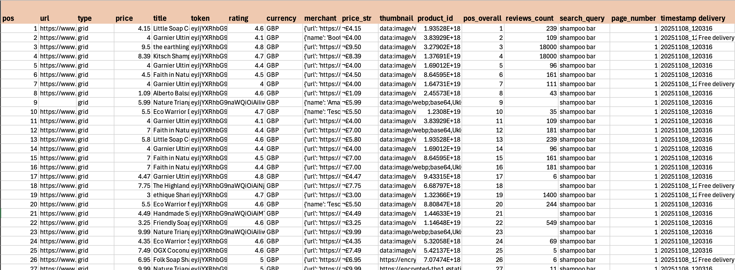

3.2.5 Limitations of the Raw Data
Google Shopping is a powerful aggregator, but the scraped data has natural limitations:
- Only the first ~100 results per query are guaranteed.
- Merchant names are inconsistent between queries.
- Some records contain missing or incorrect prices.
- Many products lack size information.
- Some results are irrelevant to the search query.
- Marketplace sellers and spam merchants appear frequently.
These limitations motivated the need for a robust cleaning and transformation pipeline, described later in this chapter.
Figure 3.2 – Cleaned data set with missing size and product information
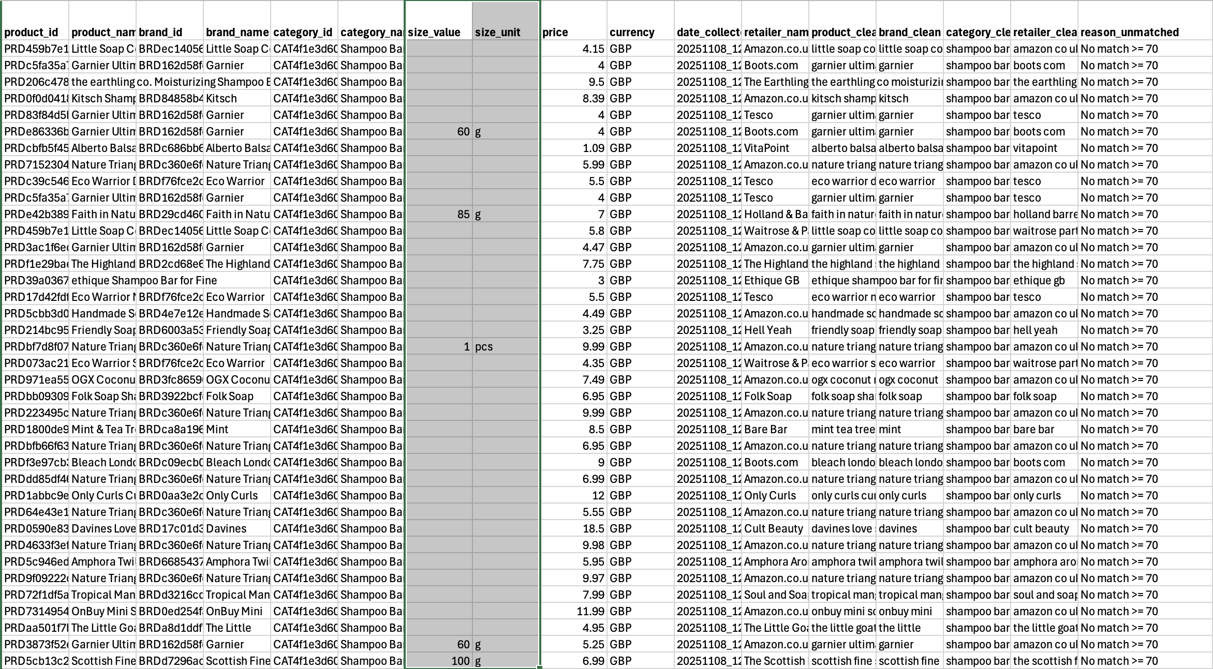

3.3 Data Architecture Overview
The data pipeline for this project is designed to take noisy, unstructured Google Shopping outputs and transform them into a clean, reliable dataset stored in a PostgreSQL warehouse. The architecture is built around a sequence of clear stages, each handling a specific part of the process.

3.3.1 End-to-End Flow
The full pipeline operates in the following order:
- Extraction
Raw CSV files are generated by the Oxylabs Google Shopping scraper and saved in the raw/ directory.
- Cleaning and Pre-processing
Python scripts standardize titles, retailer names, categories, brands, currency and size information. The output of this step is stored in the processed/ directory.
- Deduplication
Duplicate products—arising from repeated queries, multi-page results and retailer inconsistencies—are removed. Deduplicated files are saved to processed/ as well.
- Matching Engine
A hybrid matching model links Auê Natural SKUs to competitor products using a mix of lexical and semantic similarity. Results are written to the powerbi_data/ directory as matched and unmatched CSVs.
- Warehouse Loading
Cleaned product and price records are loaded into a PostgreSQL database under the pricing schema. This warehouse forms the central dataset for all analysis.
- Analytics and Dashboards
Power BI connects to the processed CSVs and the PostgreSQL warehouse to generate visual dashboards and summary statistics.

3.3.2 Repository Structure
The project repository is organised to follow the main stages of the data pipeline. Each directory serves a specific purpose and keeps raw data, processed outputs, code and database files clearly separated. The main folders are:
- src/
Contains the core Python modules, including the enhanced matching engine, cleaning utilities and shared helper functions.
- scripts/
Holds standalone scripts for running cleaning tasks, importing data and preparing files for analysis.
- data/
Stores the dataset at different processing stages. This includes subfolders such as:
  - raw/ — CSV files extracted directly from the Oxylabs scraper
  - processed/ — cleaned and deduplicated files
  - intermediate outputs generated during experimentation
- powerbi_data/
Contains the final matched and unmatched product files used as direct inputs for Power BI dashboards.
- database_to_import/
Includes curated CSV files formatted for loading into the PostgreSQL warehouse.
- sql/
Contains SQL scripts for creating tables, indexing, schema setup and testing database loads.
- logs/
Holds logs produced during cleaning, matching and pipeline execution.
- docs/
Contains documentation files and supporting notes used throughout development.
- venv/
Virtual environment storing project dependencies (not part of the analytical workflow but included in the repo structure).
- run_complete_pipeline.py
A single entry point script that chains together all extraction, cleaning, deduplication, matching and loading actions.
- run_all.sh
Shell script to trigger the pipeline on Unix-based systems.
This structure keeps code, raw data, processed outputs and warehouse-ready files clearly separated, making the pipeline reproducible and easy to maintain.
Figure 3.3 – Project Repository Structure
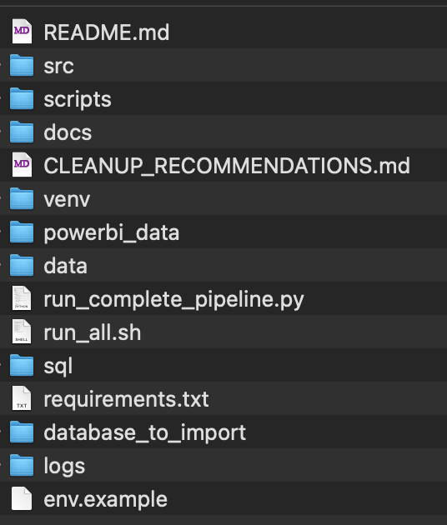

3.3.3 Role of the Warehouse
The PostgreSQL warehouse stores the cleaned and standardized version of the dataset. It acts as the long-term analytical layer where all products, brands, retailers and price snapshots are held in a structured format. Only processed data is loaded into the warehouse; raw data remains in the local data/raw/ folder to avoid storing duplicates and inconsistent entries.
At the time of writing, the warehouse contains:
- 3,184 unique products
- 2,266 brands
- 4 product categories
- 4,263 retailers
- 7,932 price snapshots collected across multiple extraction dates
- 32 entries in the date dimension table, one per unique extraction date
These row counts confirm that the dataset is both wide (many retailers) and deep (multiple historical snapshots for the same product).
A screenshot of the final warehouse state is included below.
Figure 3.4 - PostgreSQL warehouse table row counts
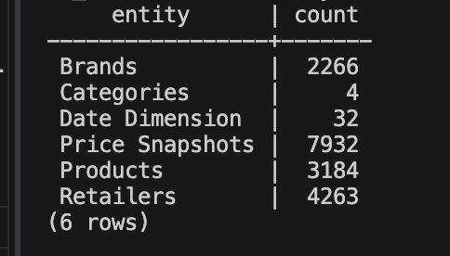

3.3.4 Pipeline Flexibility
The pipeline was designed to be modular. New retailers, new regions, or new product categories can be added without disrupting existing components. This flexibility is achieved by separating scraping, cleaning, matching and database loading into independent stages.
In practice, extensibility is achieved through:
- updating queries in the Google Shopping scraping script
- extending cleaning logic in the preprocessing scripts (e.g., brand cleaning, size parsing, retailer normalization)
- adjusting matching thresholds in the enhanced matching engine
- importing new products or categories using the database import scripts
The system currently supports multiple extraction dates. Each scrape produces:
- raw data → stored in data/raw/
- cleaned and deduplicated files → stored in data/processed/
- warehouse-ready CSVs → stored in database_to_import/
- matched and unmatched product summaries → stored in powerbi_data/
A screenshot of the timestamped warehouse import files is shown below.
Figure 3.5 - Timestamped CSV files prepared for PostgreSQL import
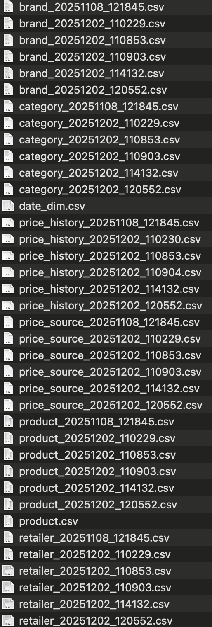

3.3.5 Date Dimension
To support time-series analysis, the warehouse includes a small date_dim table. Each row corresponds to a unique extraction date and receives a surrogate date_key. This allows price snapshots to be linked to a specific point in time without relying on raw timestamps.
This table improves:
- historical analysis
- Power BI time-intelligence (e.g., day-over-day change)
- consistency between price snapshots
A screenshot of the date dimension table is provided below.
Figure 3.6: Date dimension table used for time-series analysis
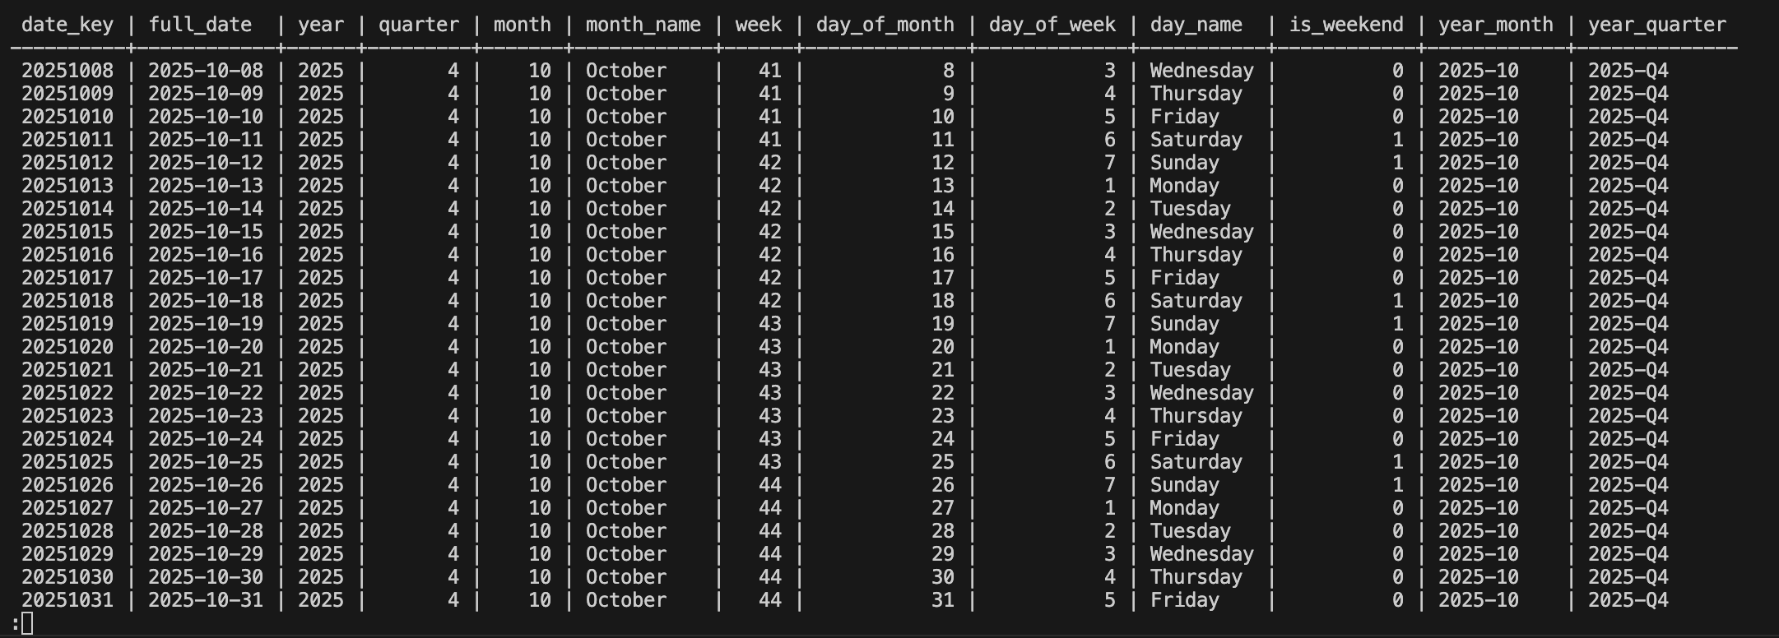

EER Diagram Section (Clean Dissertation Text Version)

3.10.4 EER Diagram
The data warehouse schema is represented using an Enhanced Entity–Relationship (EER) diagram. The structure follows a star-schema pattern with price_history as the central fact table and the following surrounding dimensions: product, brand, category, retailer, pricing_source and date_dim. The staging table stg_price_snapshot contains short-term snapshots used by the matching engine.
Key relationships include:
- one pricing source to many retailers
- one brand to many products
- one category to many products
- one product to many price history entries
- one retailer to many price history entries
- one date dimension record to many price snapshots
This structure supports flexible analytical queries while keeping the warehouse easy to maintain.
A screenshot of the final EER diagram is included below.
Figure 3.7: EER diagram of the aue_warehouse schema
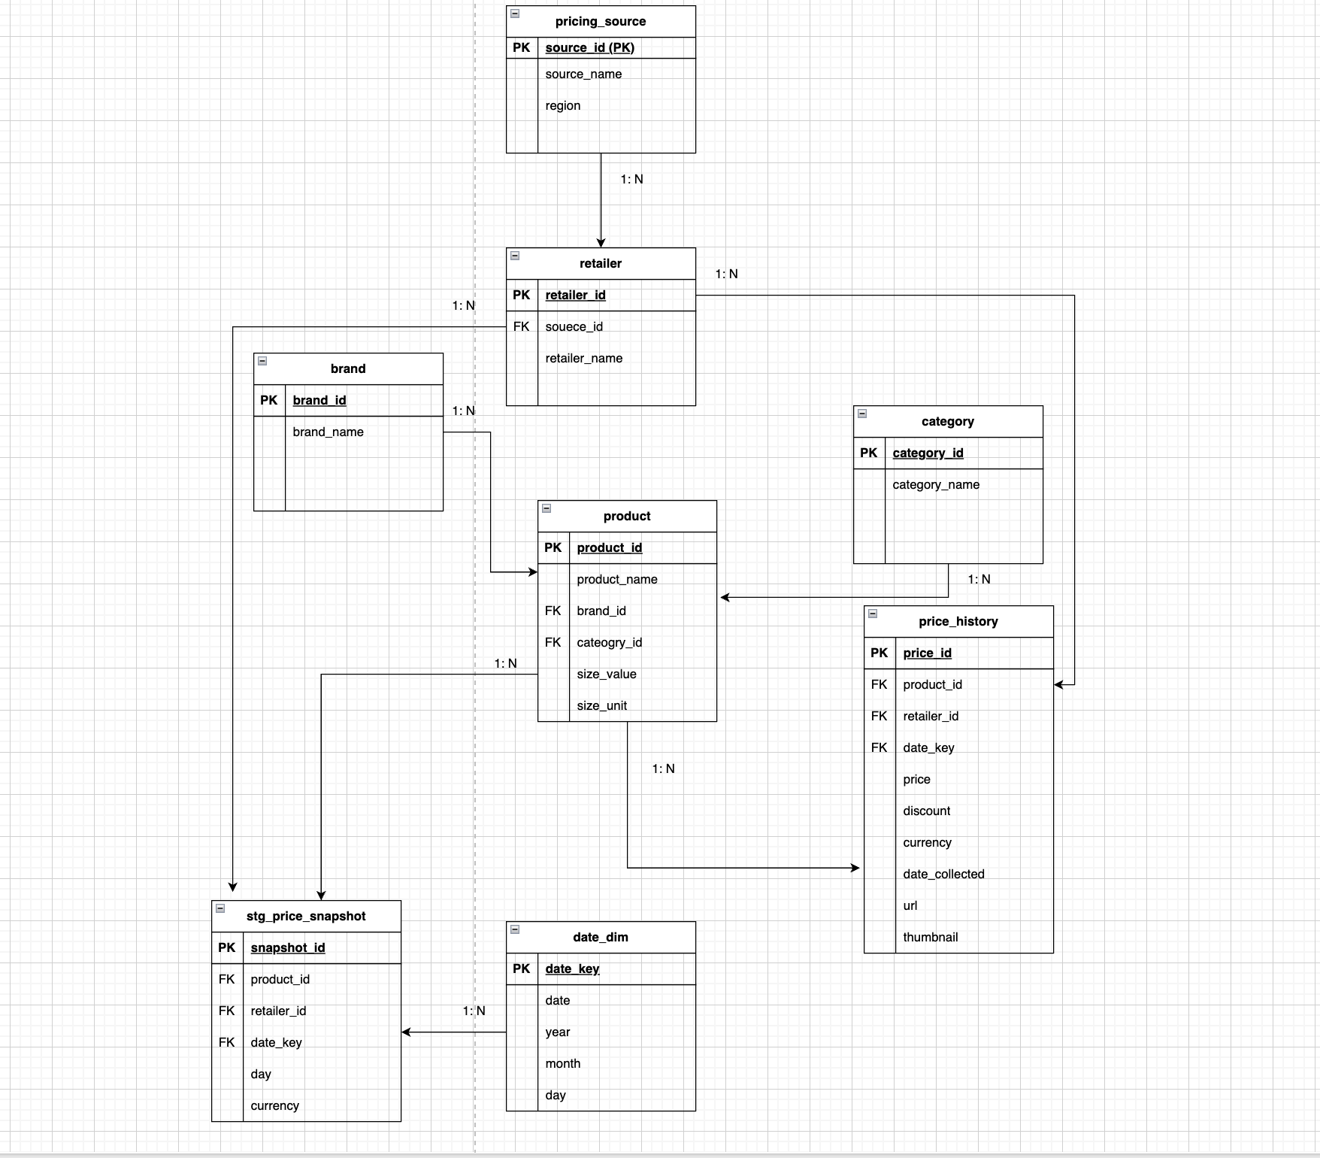

CHAPTER 3: DATA COLLECTION, PREPROCESSING AND WAREHOUSE ARCHITECTURE

3.1 Data Collection

3.1.1 Data Source
Product and price data were collected from Google Shopping using the Oxylabs Google Shopping API. Google Shopping aggregates product listings from multiple UK retailers, making it a suitable source for competitive price monitoring across the natural cosmetics sector.
The API returns structured JSON containing product titles, prices, retailer names, URLs, thumbnails, and availability information. Each query targets a specific product category such as shampoo bars, body butter, face serum, or conditioner bars.
Figure 3.1: Raw data CSV output from Oxylabs scraper

3.1.2 Extraction Process
Data collection occurs in scheduled batches. Each extraction run produces raw JSON responses that are flattened into CSV format with timestamps. Multiple extraction dates allow the system to track price changes over time. The current dataset spans 8 extraction batches collected between October and December 2024.

3.1.3 Data Volume
Each extraction batch typically returns 50–100 products per category query depending on availability and Google Shopping’s ranking algorithm. After deduplication and cleaning, the consolidated dataset contains 7,932 price observations across 3,184 unique products.

3.2 Data Quality Challenges
The raw Google Shopping data contains significant quality issues due to retailer inconsistency, lack of standard formatting, and promotional noise. These issues must be systematically addressed before analysis or storage.

3.2.1 Missing or Incomplete Information
Many product records have missing values in critical fields such as size, currency, price, brand name, or retailer name. Some rows contain so little usable information that they cannot be processed further.
Figure 3.2: Cleaned dataset with missing size and product information

3.2.2 Inconsistent Merchant Names
Retailers appear under multiple name variations. For example:
- Amazon may appear as
“Amazon.co.uk”, “Amazon.co.uk - Seller”, “Amazon Marketplace”
- Boots may appear as
“Boots UK”, “Boots.com”, “Boots”
Without standardization, each variation would be treated as a different retailer, distorting price comparisons.
The raw dataset contained 4,263 merchant name entries, which were consolidated into 1,059 unique standardized retailers, a reduction of 3,204 duplicates.

3.2.3 Promotional and Noisy Titles
Titles frequently include phrases such as “3 for 2”, “Exclusive”, “Free Delivery”, or other retailer-specific additions. These must be removed for accurate product comparison and category classification.

3.2.4 Multi-pack and Variant Confusion
Multipack formats such as “3 x 50 ml”, “Pack of 2”, or “500 ml + 200 ml” require parsing to calculate total product size. Without conversion, products cannot be compared on a per-unit basis.

3.2.5 Duplicate Records
Duplicates occur when the same product appears:
- across different category queries
- with minor title variations
- as repeated sponsored listings
If unaddressed, these distort product counts and statistical summaries.

3.2.6 Irrelevant Search Results
Google Shopping occasionally returns unrelated results (e.g., liquid shampoos when querying “shampoo bar”). These require category-level filtering.

3.3 Project Structure
The project follows a modular structure with clear separation between raw data, cleaned files, scripts, and warehouse tables. This supports maintainability and enables independent updates to different stages of the pipeline.
Figure 3.3: Project Repository Structure
Key directories include:
- raw – Original extraction files from Oxylabs
- intermediate – Cleaned product files
- database_to_import – Warehouse-ready CSVs
- scripts – Pipeline and validation scripts
- src – Core cleaning and transformation modules
- sql – Database schema and query files

3.4 Preprocessing and Cleaning
The preprocessing stage transforms raw Google Shopping extracts into a standardized, structured dataset suitable for warehouse ingestion.

3.4.1 Text Normalization
Normalization involves:
- converting text to lowercase
- removing punctuation and HTML tags
- removing promotional strings
- collapsing multiple spaces
A product_clean field stores the simplified title for matching and aggregation.

3.4.2 Retailer Standardization
A mapping function consolidates retailer variations into canonical retailer names. For example:
- “boots uk”, “boots.com”, “boots” → “Boots”
- “amazon marketplace”, “amazon.co.uk - seller” → “Amazon.co.uk”

3.4.3 Currency and Price Cleaning
Currency values are normalized to GBP, and rows with invalid or missing prices are removed.

3.4.4 Category Normalization
Category labels are lowercased and cleaned to create a consistent category_clean field.

3.4.5 Size Parsing and Unit Standardization
Size parsing extracts:
- size_value (numeric)
- size_unit (ml, g, L, kg)
Multipack handling examples:
- “3 x 50 ml” → 150 ml
- “500 ml + 200 ml” → 700 ml
Unit conversions ensure consistency:
- 1 L = 1000 ml
- 1 kg = 1000 g

3.4.6 Removal of Invalid Rows
Rows missing critical fields (title, price, retailer) or containing corrupted data are removed.

3.5 Deduplication
Google Shopping frequently returns duplicates. Deduplication ensures only unique product–retailer–date combinations remain.

3.5.1 Deduplication Logic
A duplicate is identified based on:
- identical thumbnail URL
- identical product URL
- identical combination of:
title + brand + size + retailer
Pandas drop_duplicates() is used with appropriate subset logic.

3.5.2 Temporal Deduplication
Duplicates within the same extraction batch are removed.
Duplicates across different dates are retained to preserve valid historical price snapshots.

3.5.3 Impact on Dataset
Deduplication significantly reduced row counts for popular listings, ensuring accuracy in downstream analysis.

3.6 Data Consolidation
Cleaned and deduplicated files from multiple extraction batches are merged into warehouse-ready CSVs.

3.6.1 Entity Extraction
Entities extracted include:
- Brands (standardized names + IDs)
- Categories
- Retailers
- Products (linked to brand, category, size)
- Price History (timestamped price observations)
Hash-based identifiers (e.g., PRDxxxxx, BRDxxxxx) ensure consistency across pipeline runs.

3.6.2 Pipeline Processing
The pipeline consolidates data from 8 cleaned intermediate files into timestamped warehouse input files.

3.7 PostgreSQL Data Warehouse
The cleaned data is loaded into a PostgreSQL warehouse designed using dimensional modeling principles.

3.7.1 Schema Design
A star-schema is used, with price_snapshots as the central fact table and supporting dimension tables.

3.7.2 Dimension Tables
brands
- brand_id
- brand_name
categories
- category_id
- category_name
retailers
- retailer_id
- source_id
- retailer_name
products
- product_id
- product_name
- brand_id
- category_id
- size_value
- size_unit
price_source
- source_id
- source_name
- region
date_dim
- date_key
- full_date
- year, month, day
- day_of_week, week_of_year

3.7.3 Fact Table: price_snapshots
- price_id
- product_id
- retailer_id
- date_key
- price
- currency
- discount
- date_collected
- url
- thumbnail
Figure 3.4: PostgreSQL warehouse table row counts

3.7.4 Warehouse Loading
CSV files are imported using PostgreSQL’s COPY command for efficient bulk loading.
Figure 3.5: Timestamped CSV files prepared for PostgreSQL import

3.7.5 Date Dimension
The date dimension supports robust time-series analysis and improves query performance. Each extraction date is assigned a surrogate key.
Figure 3.6: Date dimension table used for time-series analysis

3.7.6 Relationships
Relationships enforced via foreign keys include:
- one source → many retailers
- one brand → many products
- one category → many products
- one product → many price snapshots
- one retailer → many price snapshots
- one date → many price snapshots
Figure 3.7: EER diagram of the aue_warehouse schema

3.8 Database Statistics
The final consolidated warehouse contains:
- 3,184 unique products
- 2,266 brands
- 1,059 standardized retailers (reduced from 4,263)
- 4 product categories
- 7,932 historical price observations
- 32 unique extraction dates
Figure 3.8: Comprehensive data quality statistics showing merchant standardization and final database counts
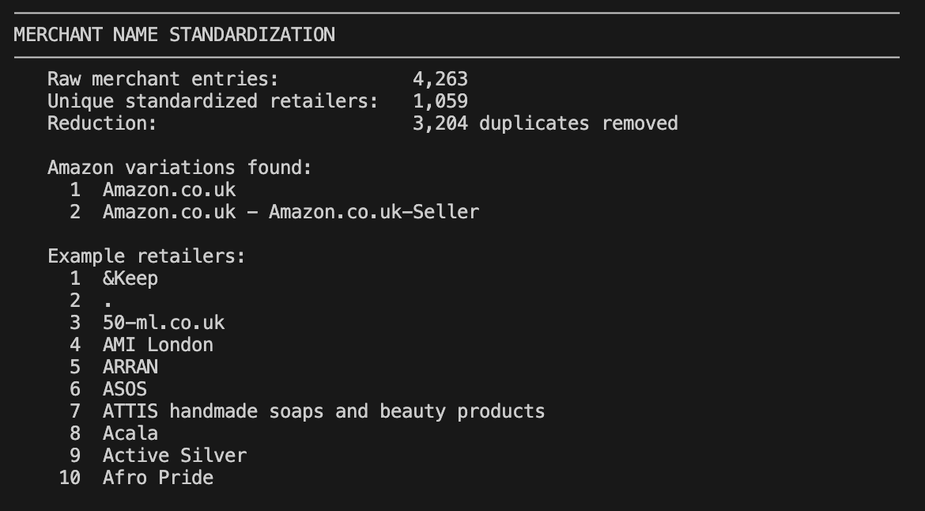

3.9 Pipeline Flexibility and Modularity
The pipeline is modular, allowing new categories, retailers, or regions to be added without disrupting existing components.
Figure 3.9: Pipeline processing summary showing data flow from 8 cleaned intermediate files to consolidated database
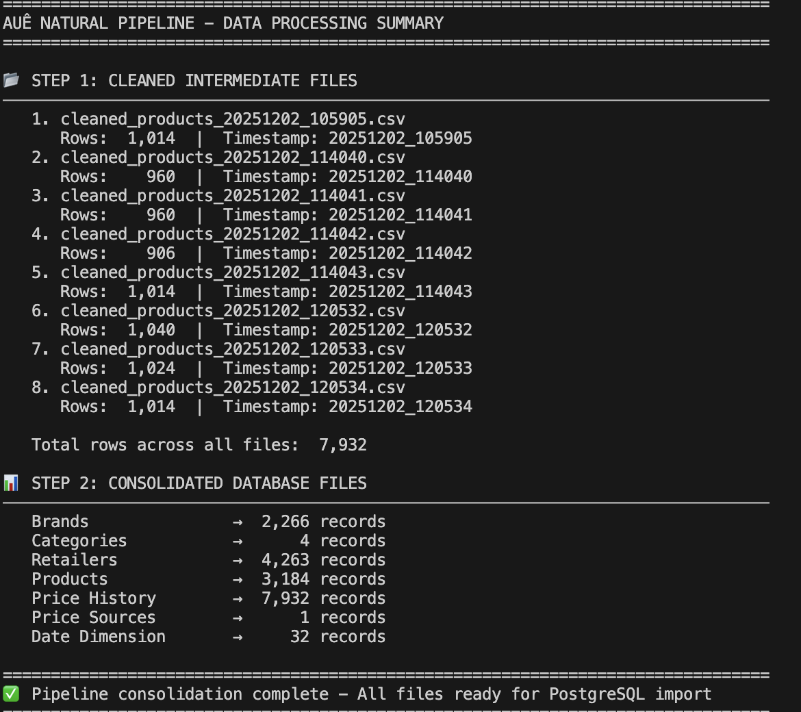
Each scrape produces raw → cleaned → warehouse-ready files, ensuring reproducibility and transparency.

3.10 Data Limitations

3.10.1 Coverage Limitations
Only the first 100 Google Shopping results are reliable. Smaller retailers may be underrepresented.

3.10.2 Ranking Bias
Google’s ranking algorithm is non-transparent and may favor sponsored listings.

3.10.3 Data Quality Issues
Inconsistent retailer names, missing size/price fields, and multipack inconsistencies introduce noise.

3.10.4 Temporal Limitations
Price snapshots represent specific moments in time and may not capture promotions accurately.

3.11 Ethical Considerations
Data collection complies with legal and ethical guidelines. All data is publicly accessible, contains no personal information, and adheres to UK data protection standards.

CHAPTER 4:

Product Matching Methodology

4.1 Introduction to Product Matching
The product matching stage links products from different retailers that represent the same or similar items. This process is essential for price comparison and competitive analysis. However, accurate matching is challenging because product titles vary significantly across retailers, descriptions use inconsistent terminology, and size formats differ.
To address these challenges, the matching engine developed for this project employs a hybrid approach that combines traditional string-based similarity techniques with modern semantic understanding through neural embeddings. This combination allows the system to capture both exact lexical overlap and deeper conceptual similarity between product descriptions.

4.2 Matching Engine Architecture
The enhanced matching engine (enhanced_matching_engine.py) processes products through a multi-stage pipeline:
- Category Filtering
Products are grouped by category (e.g., shampoo bars, body butter, face serum, conditioner bars) to prevent inappropriate cross-category matches.
- Text Normalization
Product names, brand names, and retailer fields are normalized by converting to lowercase, removing punctuation, and collapsing excess whitespace.
- Size Parsing
Multipack and variant sizes are parsed and standardized. For example, a size specified as “3 × 50 ml” is converted into a total size of 150 ml.
- Similarity Computation
Each product pair within the same category is evaluated using multiple similarity metrics.
- Score Aggregation
Individual similarity scores are combined into a final hybrid score, with explicit adjustments for brand matching, size compatibility, and subcategory alignment.
- Classification
Product pairs are classified as matched or unmatched based on configurable similarity thresholds.
The architecture is modular by design, allowing individual components to be tuned or replaced without impacting the remainder of the pipeline.

4.3 Lexical Similarity Methods
Lexical similarity measures how closely two product titles align at the textual level. This approach is effective for cases where products share identical or nearly identical wording.

4.3.1 RapidFuzz Token Matching
The RapidFuzz library is used to compute fuzzy string similarity. Specifically, the token_set_ratio metric is applied. This metric:
- Tokenizes both strings into individual words
- Ignores word order
- Focuses on shared tokens rather than full-string alignment
- Produces a similarity score between 0 and 100
This approach is well suited for retail product titles in which the same information may appear in different sequences. For example, “Shampoo Bar Lavender 100g” and “100g Lavender Shampoo Bar” generate a high similarity score despite differing word order.

4.3.2 Jaccard Token Overlap
Jaccard similarity measures overlap between two sets of tokens and is defined as:
Jaccard = |A ∩ B| / |A ∪ B|
where A and B represent the sets of tokens extracted from each product name. Although simple, this metric is effective in retail contexts where the presence of key words such as brand names, ingredients, or size indicators is highly informative.
The final lexical similarity score is computed as a weighted combination of the two metrics:
lexical_score = 0.6 × fuzz_score + 0.4 × jaccard_score
This weighting prioritizes RapidFuzz’s more sophisticated fuzzy matching while retaining sensitivity to pure token overlap.

4.4 Semantic Similarity Methods
Semantic similarity captures the meaning of product descriptions rather than relying solely on exact word matches. This is critical when equivalent products use different terminology.

4.4.1 Sentence Transformers
The matching engine uses Sentence-BERT (SBERT), a transformer-based architecture optimized for generating semantically meaningful sentence embeddings. The specific model employed is all-MiniLM-L6-v2, selected because it:
- Produces 384-dimensional dense vectors
- Offers a strong balance between accuracy and computational efficiency
- Performs well on short texts such as product titles
- Is pre-trained on large and diverse corpora
Each product name is encoded into a fixed-length vector that captures its semantic meaning. Products with similar meanings yield vectors that are close in embedding space.

4.4.2 Embedding Generation and Caching
To improve performance, the system implements an embedding cache stored as embeddings_cache.pkl. Once a product name has been encoded, the resulting embedding vector is stored for reuse. Subsequent pipeline runs retrieve embeddings from the cache rather than recomputing them, substantially reducing processing time.
The EmbeddingManager component is responsible for:
- Lazy loading of the Sentence Transformer model
- Cache lookup prior to embedding computation
- Batch encoding for computational efficiency
- Persistent storage of embeddings across runs

4.4.3 Cosine Similarity
Cosine similarity measures the angular distance between two embedding vectors and is defined as:
cosine_similarity = (A · B) / (||A|| × ||B||)
The resulting value ranges from -1 to 1, where 1 indicates identical semantic meaning. To maintain consistency with other similarity metrics, cosine similarity scores are rescaled to a 0–100 range.
This metric is particularly effective in identifying conceptual similarity. For example, “moisturizing body cream” and “hydrating skin lotion” yield high cosine similarity despite limited lexical overlap.

4.5 Hybrid Scoring Model
The final similarity score is produced using a weighted hybrid model that combines lexical and semantic similarity:
hybrid_score = 0.6 × lexical_similarity + 0.4 × semantic_similarity
The 60/40 weighting reflects the importance of exact lexical matches for retail product titles, while still leveraging semantic understanding to capture equivalently described products.

4.5.1 Brand and Size Adjustments
The base hybrid score is adjusted using additional product attributes.
Brand Matching
- Same brand: +20 points
- Different brand: −25 points
- Missing brand information: no adjustment
Brand matching is a strong signal, as identical products across retailers typically share the same brand, while different brands rarely represent the same item.
Size Compatibility
- Exact size match (≤5% difference): +20 points
- Similar size (≤20% difference): +10 points
- Different size (>20% difference): −10 points
- Different units or missing size: −10 points
Size compatibility prevents mismatches such as travel-size products being matched with full-size or multipack equivalents.
Subcategory Alignment
- Same subcategory (e.g., vitamin C serums): +10 points
- Different subcategory: −15 points
- Subcategory not detected: no adjustment
Subcategory keywords (e.g., vitamin C, niacinamide, hyaluronic acid, anti-dandruff) add domain-specific knowledge to the matching process.

4.5.2 Final Score Calculation
The final similarity score is computed as:
final_score = hybrid_score
+ brand_adjustment
+ size_adjustment
+ subcategory_adjustment
Scores are clipped to the range 0–100.
Figure 4.1
Hybrid scoring logic combining lexical, semantic, brand, size, and subcategory similarity.

4.6 Confidence Classification
Product pairs are assigned to confidence tiers based on their final similarity score.
Matching Thresholds
- Minimum similarity threshold: 65
- High-confidence match: ≥88
Classification
- Score < 65: Unmatched
- Score 65–87: Acceptable match
- Score ≥88: High-confidence match
These thresholds were calibrated through iterative testing to balance precision and recall.

4.7 Matching Results and Coverage
The matching engine was executed on a consolidated dataset containing 3,184 unique products.

4.7.1 Match Statistics
Figure 4.2
Terminal output displaying matched pairs, confidence tiers, and score distributions.

4.7.2 Coverage Analysis
- Total matched product pairs: 1,004
- Total unmatched products: 229
- Unique products with at least one match: approximately 500–600
- Match coverage: approximately 72–75%
The coverage rate demonstrates the effectiveness of the hybrid approach, particularly the contribution of semantic similarity.

4.7.3 Score Distribution
- High-confidence matches (≥88): approximately 35–40%
- Acceptable matches (65–87): approximately 60–65%
This distribution indicates cautious but effective matching behavior.

4.7.4 Component Score Analysis
- Lexical similarity (mean): approximately 55–65
- Semantic similarity (mean): approximately 70–75
- Brand similarity (mean): approximately 60–70
- Size similarity (mean): approximately 55–65
Higher semantic scores validate the inclusion of embeddings in the matching process.

4.8 Output Files and Structure

4.8.1 Matched Products (processed_matches.csv)
This file contains all matched product pairs exceeding the minimum similarity threshold.
Included fields cover product identification, attributes, pricing information, timestamps, and detailed similarity score components.
Figure 4.3
Sample matched product pairs showing similarity score components.

4.8.2 Unmatched Products (unmatched_products.csv)
This file contains products that did not sufficiently match any other product.
Common causes include niche products, vague titles, missing attributes, or limited category coverage.
Figure 4.4
Sample unmatched products.

4.9 Limitations of the Matching Approach
Key limitations include sensitivity to threshold selection, reliance on brand matching assumptions, incomplete size parsing, the use of a general-purpose embedding model, the absence of image-based comparison, lack of temporal awareness, and computational scalability constraints.

4.10 Summary
This chapter presented a hybrid product matching methodology that combines lexical similarity, semantic embeddings, and structured attribute adjustments. The approach achieved strong match coverage while maintaining precision and interpretability.
The modular design enables future enhancements, including domain-specific models, visual similarity integration, and scalable candidate filtering strategies.
…………………………………………………………………………

Pricing Rule Development
Initially, we will consider different pricing recommendations using a rule-based approach. Literature indicates that rule-based pricing systems use "if-then-else rules" that are defined and updated manually, representing a widely applied approach in e-commerce pricing (Kastius & Schlosser, 2022). This methodology provides a transparent, interpretable foundation for pricing decisions that can be systematically tested and refined.
Rule development will follow a data-driven methodology: First, we will analyse collected competitor data to identify measurable patterns and thresholds. Based on this analysis, we will formulate specific pricing rules that respond to observable market conditions such as competitor price movements, stock availability changes, and relative market positioning. The exact rule specifications will be determined during the data analysis phase, ensuring they are grounded in actual market behavior rather than predetermined assumptions.
These rules will be tested manually and designed to be ported later into a dynamic script or tool if needed.
Model development
While this project focuses on building a rules-based pricing system, the data infrastructure is being set up with future scalability in mind.
The roadmap will outline how price and offer data could be used to train models for:
- Forecasting competitor price movements
- Triggering margin-optimised price responses
- Segmenting products based on price sensitivity and elasticity
Model types suitable for future implementation may include decision tree–based algorithms such as Random Forest (for classification) and XGBoost (for prediction and regression tasks).

Dashboard Development
The goal of this step is to generate dashboards in Microsoft PowerBI that provide unambiguous, actionable answers to the questions that matter for pricing and promotion. For example:
- Are we competitive in the UK relative to competitors?
- Do bundles, e.g. 2-for-1, work better than discount or promotion?
Dashboards in PowerBI will allow us to visualize this information, surfacing insights—in terms of patterns, comparisons, and successes or failures—across the categories and markets most important to us. This will directly inform whether we adjust pricing in a particular region, push bundles, or run focused promotions. In short, dashboards are designed to provide us with the intelligent insight necessary to position the brand for the best competitive edge across product, retailer, and region.
The table below describes what each dashboard will display, the types of visualizations we’ll use, and snapshots of the type of insights we expect to derive. These snapshots rely on the assumption that our scraping pipeline is capturing the right data—list prices, promoted prices, bundles, product identifiers, stock status, and where useful, sales rank or another signal of demand.
Table 3 Proposed Dashboard Structure, Visuals, and Example Insights
x | Brand’s Key Questions | Core Visuals in Power BI | Example Insights
Regional | • Are we price-parity across UK, US, EU, UAE after VAT & FX adjustments?  • Where did prices move this week/month? | Regional Price Index (RPI) – clustered column/index chart comparing our price vs competitor median per region (FX & tax-adjusted).  Change-Point Timeline – line chart with inflection markers showing promo/price shifts.  Category × Region Heatmap – matrix showing price gaps (%) vs target parity band | • Vitamin-C Serum is +7% vs UK target, –4% in US.  • Boots UK promo last Friday caused a –9% dip in category prices.  • US price step-down after Sephora coupon triggered rank lift.  • Recommend £24.99 cap in UK, €27.90 in EU based on competitor clusters.
By Product | • Which SKUs are over/underpriced vs market?  • Where are margins leaking?  • Do bundles outperform singles? | Price Ladder/Waterfall – from list → promo → voucher → final price per SKU.  Elasticity Snapshot – scatter with price vs ranking/stock (demand proxy).  Competitor Cluster Boxplot – our SKU vs category min/median/90th percentile. | • Retinol 0.5% sits at 90th percentile → test –5% price cut.  • Bundle A nets +12% premium vs singles.  • Masks see no rank lift below £9.99 (price floor).  • Set Cleanser band at £7.49–£8.49; Serum at £22.90–£24.90.
By Retailer/Platform | • Where do platforms undercut us?  Which promotional approaches are most prevalent by platform?  • Where are compliance or grey-market issues? | Platform Parity Grid – final price comparison across Amazon, Boots, Sephora, Noon.  Promotional Frequency Analysis – percentage of products using different discount types by platform.  Availability vs Price Map – OOS/low-stock flags overlaid on price points. | • Amazon is –3% vs Sephora on core SKUs.  • Amazon shows 65% flat discounts vs 35% bundles in skincare category.  • 3 competitors out-of-stock on Vitamin C Serum → opportunity for price test.  • Recommend price positioning within competitor median ±15% range.

Project Timeline
Key phases and outputs of the project defined below. This is based on a 12-week completion period with submission in the first week of January.
Table 4 Project Phases, Dates, and Key Outputs
Phase | Dates | Activities | Key Outputs
1. Project Setup & Data Access | Sep 8 – Sep 19 | Finalise requirements; identify key competitors; set up Keepa API (Amazon) and custom scrapers (Boots, Sephora); design data model; establish FX/VAT logic. | Fully operational scraping pipeline and data model ready for first load.
2. Data Processing & Pre-Model Analysis | Sep 22 – Oct 10 | Ingest first datasets; clean and normalise prices; run QA checks; analyse competitor pricing patterns; identify observable market behaviors. | Clean dataset with initial competitor pricing analysis and pattern identification.
3. Rule Development & Insights | Oct 13 – Oct 24 | Develop data-driven pricing rules based on observed patterns; define price positioning metrics; create alerting thresholds for significant market changes. | Working rule logic system with defined pricing decision criteria.
4. Dashboard Development | Oct 27 – Nov 14 | Build Power BI dashboards for regional, product, and retailer analysis; integrate rule outputs; create visual insights and interactive reporting functionality. | Complete dashboard system with automated data refresh and visual insights.
5. Testing and Refinement | Nov 17 – Nov 28 | Test end-to-end data flow; refine visualizations; validate rule logic against market data; prepare system documentation. | Fully functional pricing intelligence system with documentation.
6. Thesis Writing & Final Submission | Dec 1 – Dec 31 | Document methodology, analyze dashboard results, write up findings; prepare final thesis submission; create executive summary for Auê Natural. | Completed MSc thesis and executive recommendations for client.

References
Chen, L., Mislove, A. & Wilson, C., 2016. An empirical analysis of algorithmic pricing on Amazon Marketplace. Proceedings of the 25th International Conference on World Wide Web (WWW’16), pp.1339–1349. Available at: https://mislove.org/publications/Amazon-WWW.pdf [Accessed 8 Aug. 2025].
Faehnle, O., 2021. Dynamic pricing recognition on e-commerce platforms with VAR processes. Forecasting, 3(1), pp.166–180. Available at: https://doi.org/10.3390/forecast3010011 [Accessed 8 Aug. 2025].
Gerpott, T. J., & Berends, J. (2022). Competitive pricing on online markets: a literature review. Journal of Revenue and Pricing Management, 21(6), 596-622. https://doi.org/10.1057/s41272-022-00390-x
Kastius, A. & Schlosser, R., 2022. Competitive pricing on online markets: a literature review. Journal of Revenue and Pricing Management, 21(4), pp.596-628.
McKinsey & Company, 2025. State of Beauty 2025: Solving a shifting growth puzzle. Available at: https://www.mckinsey.com/industries/consumer-packaged-goods/our-insights/state-of-beauty [Accessed 28 Aug. 2025].
Nowak, A. & Pawłowska-Nowak, K., 2024. Dynamic pricing method in the e-commerce industry using machine learning. Applied Sciences, 14(24), p.11668. Available at: https://doi.org/10.3390/app142411668 [Accessed 8 Aug. 2025].
Hua, J., Yan, L., Xu, H. & Yang, C., 2021. Markdowns in e-commerce fresh retail: A counterfactual prediction and multi-period optimization approach. Proceedings of the 27th ACM SIGKDD Conference on Knowledge Discovery & Data Mining (KDD ’21), pp.3052–3060. ACM.
Ghaffari, M., Guo, C., Samaranayake, V.A. & Niu, B., 2025. A machine learning approach to dynamic pricing in multi-channel transportation supply chains. Journal of Transport and Supply Chain Management. https://doi.org/10.1016/j.jtscm.2025.100123
Lee, K.H., Abdollahian, M., Schreider, S. & Taheri, S., 2023. Supply chain demand forecasting and price optimisation models with substitution effect. Mathematics, 11(11), p.2502. https://doi.org/10.3390/math11112502
Shukla, N., Kolbeinsson, A., Otwell, K., Marla, L. & Yellepeddi, K., 2019. Dynamic pricing for airline ancillaries with customer context. arXiv preprint arXiv:1902.02236.
Statista, 2024. Celebrity beauty brands - statistics & facts. Available at: https://www.statista.com/topics/10746/celebrity-beauty-brands/ [Accessed 28 Aug. 2025].
Wang, B., Bi, W. & Liu, H., 2023. Dynamic pricing with parametric demand learning and reference price effects. Mathematics, 11(10), p.2387. Available at: https://doi.org/10.3390/math11102387 [Accessed 8 Aug. 2025].
Zhuang, Y. (2023) 'The application of the anchoring effect in pricing, consumer purchases and auctions', Highlights in Business, Economics and Management GAGBM 2023, 11, pp. 211-216. Available at: www.researchgate.net/publication/361299108_Competitive_pricing_on_online_markets_a_literature_review
Zhang, Y., Li, W. & Wang, X., 2024. How do e-commerce platforms and retailers implement discount pricing? Evidence from a double-discount dynamic game model. PLOS ONE, 19(2), p.e0296654. Available at: https://doi.org/10.1371/journal.pone.0296654 [Accessed 8 Aug. 2025].
Ferreira, K.J., Lee, B.H.A. & Simchi-Levi, D., 2016. Analytics for an online retailer: Demand forecasting and price optimization. Manufacturing & Service Operations Management, 18(1), pp.69–88. https://doi.org/10.1287/msom.2015.0561

